2 February- World Wetlands Day

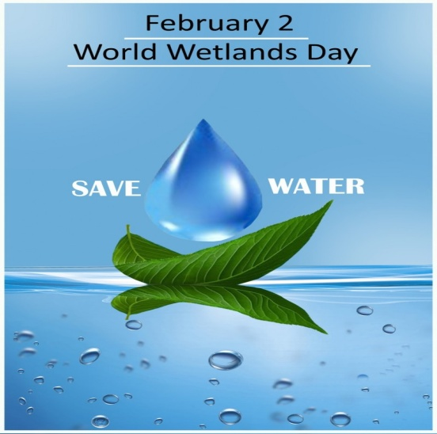
World Wetlands Day marks the anniversary of the signing of the Convention on Wetlands of international importance, especially for aquatic birds habitat, in Ramsar, Iran, on 2 February 1971.

Known as Ramsar Convention, the document that entered in force at the end of 1975 is an intergovernmental treaty that provides a framework for national action and international cooperation for the conservation and wise use of wetlands and their resources. The Convention is one of the first treaties of this kind that refers to conservation of the natural patrimony.
Wetlands have been defined as expanses of swamps, marshes, water natural or artificial, permanent or temporary, where water is stagnant or flowing, fresh or salt, including stretches of sea water with a depth at low tide does not exceed six meters.
The stated objective of the Convention is to conserve wetlands, fauna and flora that serve as Waterfowl Habitat, and on the other hand are the most important resources of economic, natural, scientific and recreational value. These areas cover only 1% of the planet, but are vital for the bio-geo-chemical cycles between land, atmosphere and hydrological systems, at the regional and global scale.
According to the Ramsar Convention, the selection of these areas is based on the international role they have from ecological, biological, zoological and hydrological point of views, given their importance as an all seasons habitat for waterfowl. Additionally, the Convention sets for the States Parties requirements related to development and implementation of management plans aimed at conservation of these areas, by creating reserves and by rational use of the natural resources.
The International Union for Conservation of Nature (IUCN) recorded by now more than 300 of wetlands. The list of the International Union for Conservation of Nature published on 29 January 2014 includes 2.177 of world wetlands (Ramsar sites), covering over 208.518.409 ha.
The international theme for World Wetlands Day 2015 is Wetlands for Our Future. The future of humanity depends on wetlands. This ecosystem provides and purifies our water, while replenishing the groundwater. So, the celebration of the day aims at help in turning the tide and helping to create awareness of just how essential wetlands are for our future
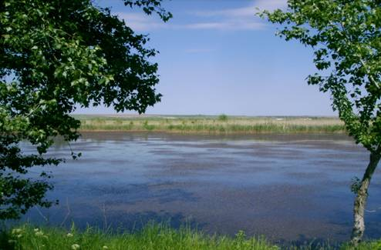. 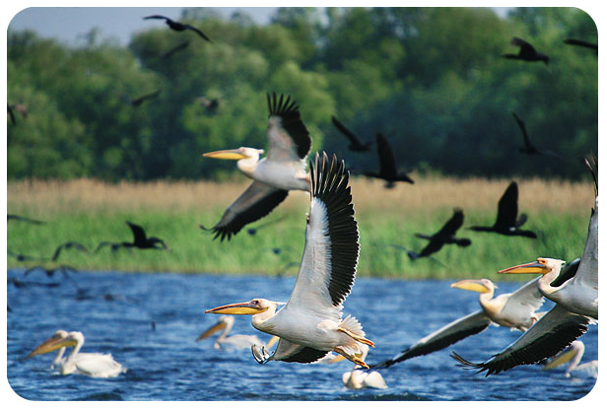

21 March - International Day of Forests
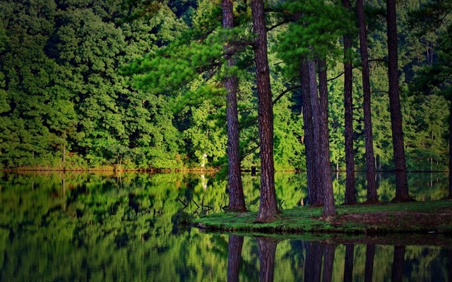
Mankind has not raised the issue of forest importance until very late, since the nineteenth century, as a result of socio-economic changes that have significantly increased the use and exploitation of timber.
According to the EU Forest Action, the forests represent a very important area for the European Union: they cover 37,8 % of the European land and provide the existence for 3,4 millions people (forestry and forest-based industries). Additionally, EU is the second biggest industrial roundwood producer after USA and produces around 80 % of the cork at global level.
In the context of climate change, forests play an important role, not only because of capturing the carbon dioxide, but also being a source of biomass and potential for renewable energies. Finally, forests are important from social and cultural point of view: are attractive for urban population, are location for entertainment activities beneficial to health and are an important cultural heritage.
As regards its climate regulation and air quality maintenance function, it should be noted that the forest gather on relatively small area a significant amount of vegetable biomass (trees, shrubs, herbaceous plants) engaged in the process of photosynthesis. Thus, it ensures the consumption of carbon dioxide originated from various sources, releasing at the same time, oxygen. 1 hectare of forest absorbs annually about 16 tons of CO₂ and produces about 30 tons of O₂ during photosynthesis.
The "purification" effect appears for a wider range of pollutants - sediment particles, sulphur dioxide, radioactive elements – retained mechanically or absorbed by foliages.
At local scale, forests provide a specific local climate, by moderating the temperature extremes (during summer, the temperature in the woods is approx. 2 degrees lower than outside it), lowering the intensity of solar radiation, increasing the relative air humidity by forming above the forest of an upward humid airflow, increasing the frequency of the atmospheric calm and lowering the wind speed, distributing uniformly the precipitations and increasing their quantity. The foliage of trees retain on average of 40-50% of rainfall.
The forests contribute to the formation of water reserves and regulate the rivers flow regime, by infiltration or by decreasing the amount of water drained from the surface, slowing the rate of leakage and reducing the maximum flood flows.

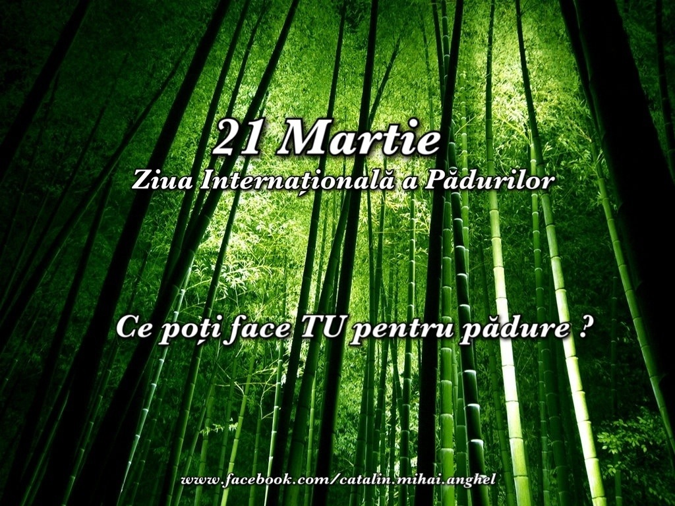
It also contributes to the soil protection, by preventing erosion and degradation (avoid landslides, sandy soils fixation), as well as by intensification of the solidification process. Forests also contribute to the protection against land erosion by fixing the substrate with roots, especially on slopes, thus reducing the likelihood of landslides and collapses.
22 March – World Water Day
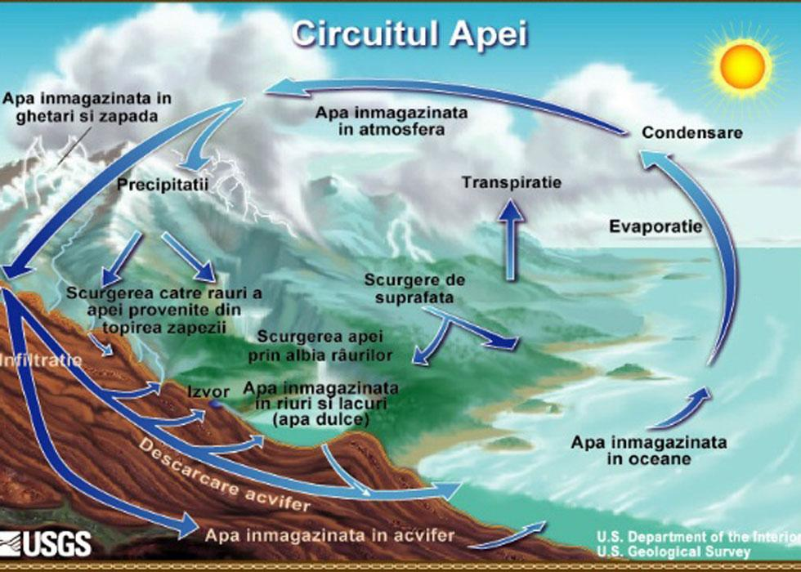
The 22 March was designated as World Water Day at the 1992 United Nations Conference on Environment and Development. Each year, a specific aspect of water is highlighted
In 2015, the theme for World Water Day is 'Water and Sustainable Development'. It’s about how water links to all areas we need to consider to create the future we want. This issue is also the theme of the annual UN World Water Development Report which is launched on World Water Day.
At global level, 70% of drinking water is used for irrigation. Irrigated land shares about 20% of agricultural land but produces 40% of the globally consumed food. Among the EU countries, Romania ranks first for degree of population dissatisfaction with the quality of water, 94% of our population considers this a real problem. The survey, conducted among the 27 EU Member States shows that 91% of Italians and 89% of French considere the water quality a great problem in their country and 59% of Finns, 58% of Austrians and 52% of Germans think that it there is no serious problem with water in their countries.
Three out of every four Europeans (i.e. 73%) believe that the EU should consider additional measures to solve the water issues. The most popular measures are higher fines for polluters, an equitable pricing policy or financial incentives.
The cleanest springs and, therefore the most precious are found within the protected areas. Among other services provided by the natural protected areas, the drinking water gains the lead.

23 March – World Meteorological Day

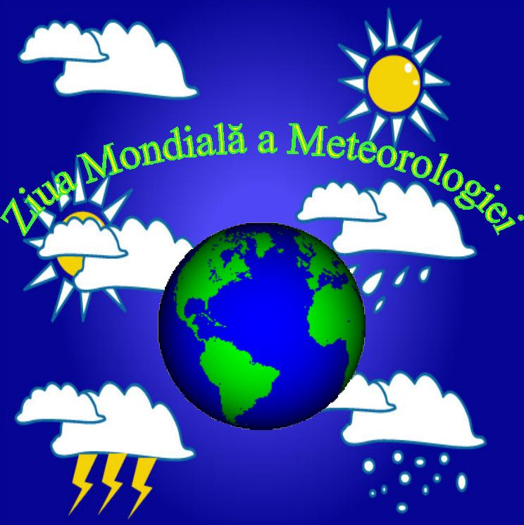
World Meteorological Day is celebrated every year to mark the entry into force on 23 March 1950 of the Convention of the World Meteorological Organization (WMO) and the significant contribution made by national hydrometeorological services for the safety and welfare of society. The theme proposed by WMO in this year is “Climate knowledge for climate action”. The theme for this year could not be timelier as the international community moves towards ambitious decisions and action to address climate change.
Weather forecasts have been a part of everyday life since the mid twentieth century. Before going to work or school, people check the weather in order to know how to dress and how to keep safe. Weather forecasts help farmers, emergency workers and other decision makers in weather-sensitive sectors to schedule their daily and weekly work priorities. These forecasts are becoming ever more reliable – today’s five-day weather forecast is as good as the -day forecast of 25 years ago – thanks to advances in weather and climate science and in computing power.
Researchers are using improved observations and greater computing power to study and predict natural cycles and broader patterns in the climate system. As a result, they can provide increasingly useful seasonal climate predictions. For example, they can assess the probability that the next season will be hotter or wetter than usual.
In addition to greater knowledge about natural climate variability, scientists have made enormous progress in understanding how humanity’s greenhouse gas emissions are changing the climate. Drawing on climate science and scenarios of greenhouse gas concentrations, they can project how the climate will change, and they can assess vulnerabilities and likely impacts in specific regions. This knowledge is invaluable for longer-term planning.
Observations of weather and climate parameters are an essential starting point for climate knowledge. Such data are gathered by the land, marine, aircraft and satellite observation networks of national meteorological and hydrological services. At the backbone of that network – the WMO Global Observing System – are over 11 000 land-based weather stations and 1 300 upper-air stations and radiosondes.
In addition to weather variables such as temperature and rain, climate knowledge is built on data about levels of greenhouse gases, pollutants and aerosols, which can affect the climate, air quality, human health, and natural and human systems. The monitoring of atmospheric chemistry is coordinated by the WMO Global Atmosphere Watch.
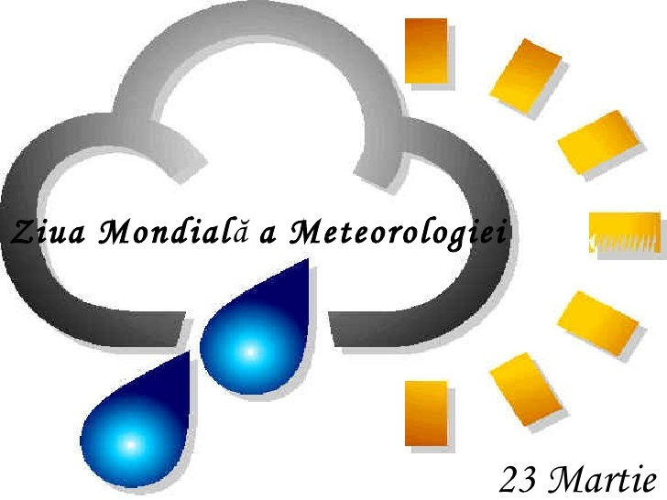
The National Meteorological and Hydrological Services of the 191 WMO Members are honing climate knowledge to permit humanity to address the benefits and threats of climate change.
29 March – Earth Hour
The event is held worldwide annually in the last Saturday of March.
The Earth Hour initiative became a tradition in the Republic of Moldova as it is encouraging everybody to turn off their lights for one hour, as a symbol for their commitment to the planet and the need to reduce the negative impact of the human activity on the environment.
The Earth Hour is marked in our country since 2008, and since 2007 at international level, when WWF Australia held the event for the first time. On 31 March 2007, more than 2 million Sydney businesses and households turned off their lights for one hour.
In 2008, over 50 million people all over the world participated in the Earth Hour action, and in 2010 - 4.500 cities from 128 countries. At present, 2 billion people from 162 countries of the world (more than 7000 cities) are supporting the Earth Hour celebrations.
Ministry of Environment invited all the institutions, businesses and citizens who care about the fate of Planet Earth, urging them to support the initiative to disconnect electricity in public places, institutions and private houses residential blocks for an hour, on 29 March, from 20.30 to 21.30.
"Earth Hour" is held annually since 2007 and, although Moldova joined it in 2008 it aims to raise awareness of government institutions and the general public on the need of involvement in promoting strong measures to halt global warming.

1 April - International Bird Day
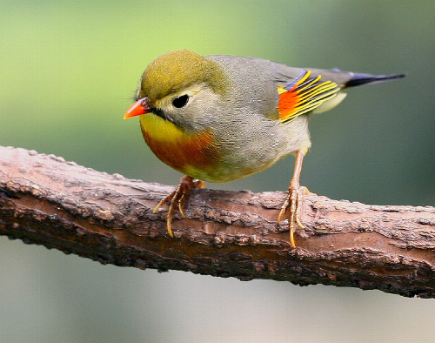
April is celebrating as international bird’s day. The international Convention for the Protection of Bird was signed on 1 April 1906 year and represents one of the first ecological documents. This tradition was revived in 1993 by Romanian Ornithological Society and since March 1994, the Bird Day is celebrated every year.
For most people, April 1 is the fool` day, however, for bird lovers and ornithologists this day marks the International Day of Birds. This day is also annually marked within the UNESCO program "The Man and the Biosphere" that is being celebrated in April as well.
The theme of the holiday is the conservation of bird species diversity and the preservation and increase of their populations. The day marks the beginning of the birds return to northern parts from their wintering sites. It is the first ecological event of April aimed at awareness rising among the young generation on issues related to protection and conservation of birds.
Over the years, the birds were inspiration for singers, painters, writers, movies, jewelers and even aircraft engineering. In the article published on www.green-report.ro, head of the Aerospace Engineering Department and author of "Aerodynamics of Low Reynolds Number Flyers" noted: "The birds certainly have some varied mechanical properties that we still do not have incorporated into engineering processes. They are lighter, have much more adaptive structures and aerodynamics capabilities integrated in their wings and body shape that are always changing. Birds have incredible capabilities to remain intact during wind, rain and snow."
"There is a legend about a bird which sings just once in its life, more sweetly than any other creature on the face of the earth. From the moment it leaves the nest it searches for a thorn tree, and does not rest until it has found one. Then, singing among the savage branches, it impales itself upon the longest, sharpest spine. And, dying, it rises above its own agony to outcarol the lark and the nightingale. One superlative song, existence the price. But the whole world stills to listen, and God in His heaven smiles. For the best is only bought at the cost of great pain… Or so says the legend"- the legend is taken from the The Thorn Birds, a popular film of the 80`s.
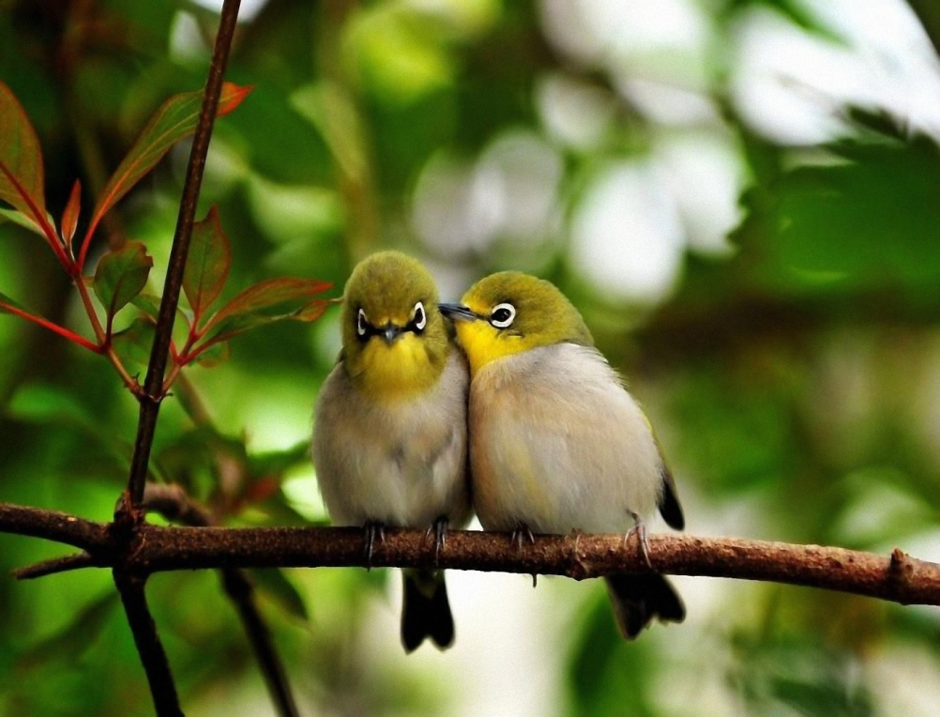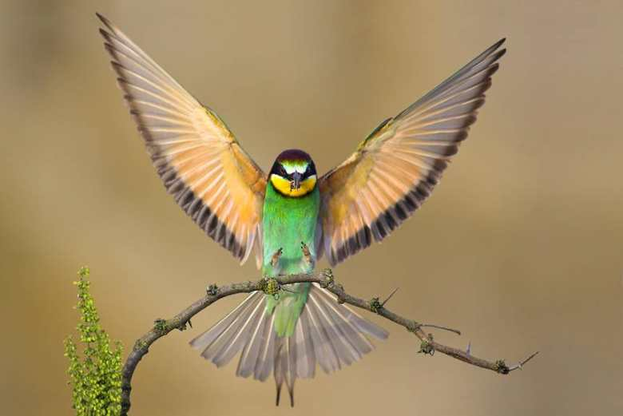
22 April – Earth Day. The official planet dedicated day for a clean and green future
The Earth Day focuses on awareness rising of millions of people to create a sustainable and healthy environment, by mobilizing communities around the world. Today, more than half of the world’s population lives in cities. As the urban population grows and the effects of climate change worsen, we, the citizens, must build and develop the cities by providing optimal conditions for life.
For the next two years, the campaign '' Green Cities' will mobilize the global population for a new era of 'green cities', which will be able to provide specific ecosystems for other creatures besides human.
Every year, on April 22, more than 190 countries organize public events at community, national and international levels to protect the planet. Climate change consequences are presented by exposing the relevant materials on giant screens or posters.
From San Francisco to San Juan, from Beijing to Brussels, from Moscow to Marrakesh, peoplewill plant trees, clean up their communities, and undertake other activities within the 'green campaign' in order to protect the environment.
Earth Day 2007 was one of the largest Earth Days to date, with many people participating in the activities in thousands of places including Kiev, Ukraine; Caracas, Venezuela; Tuvalu; Manila, Philippines; Togo; Madrid, Spain; London; and New York. The total number of participants was estimated at one billion.
The plant Earth Day was initiated by US Senator Gaylord Nelson as a day of struggle against pollution. The symbol chosen for this celebration of planet Earth is the Greek is a green version of the Greek letter theta, which represents peace or a warning.
15 May - International Day of Climate Action
The international climate day marked on 15 May is important for the reason that it wants to indicate the need to preserve the environment, because all its changes automatically lead to climate changes that can reflect negatively in the quality of life on Earth, and thus of men themselves.
In recent years, climate change has both a significant impact on natural ecosystems, biodiversity, natural resources, as well as on human health.
In the second half of the twentieth century, the issues of climate change are arising more frequent and in the 80`s scientific evidence on the risk of global climate change were found. So, in 1992, during the Rio de Janeiro Summit, the United Nations General Assembly presented for signature the United Nations Framework Convention on Climate Change. The ultimate objective of the Convention is to stabilize greenhouse gas concentrations in the atmosphere at a level that would prevent dangerous anthropogenic interference with the climate. Moldova ratified the United Nations Framework Convention on Climate Change (UNFCCC) on 9 June 1995.
The climate of the Republic of Moldova is also getting warmer. The data analysis of the last century (1860-2000) conducted by State Hydrometeorological Service experts showed that today we live in other climate conditions than our ancestors lived 100 years ago. From the late nineteenth century the average annual temperature has increased by 0,7^{о} С.
Combating global warming can be achieved both, by government action and through individual actions of population. "Daily Mail" offers a short list of such measures:
- Replacement of conventional light bulbs with low consumption light bulbs lowers the CO₂ emissions related to electricity production by 1 ton/year;
- Turn off the TV, instead of leaving it on standby mode contributes to reduction of emissions by 1 tonne of CO₂ / year for every 10 families;
- Using the public transport instead of the car decreases the emissions by 3 tonnes of CO₂ / year per person;
- When going to vacation take the train instead of plane as it may lower the emissions by 2 tonnes CO₂ / year.

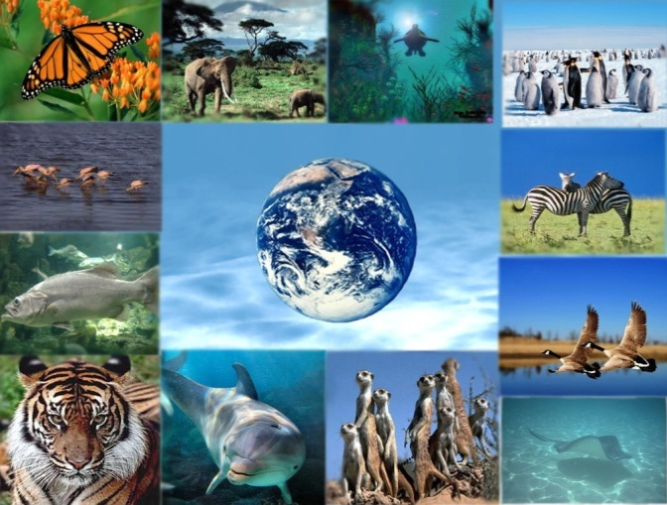
22 May- International Day for Biological Diversity
The United Nations has proclaimed 22 May as the International Day for Biological Diversity (IDB) to increase understanding and awareness of biodiversity issues.
When first created by the Second Committee of the UN General Assembly in late 1993, 29 December (the date of entry into force of the Convention of Biological Diversity), was designated The International Day for Biological Diversity. In December 2000, the UN General Assembly adopted 22 May as IDB, to commemorate the adoption of the text of the Convention on 22 May 1992 by the Nairobi Final Act of the Conference for the Adoption of the Agreed Text of the Convention on Biological Diversity.
The Convention on Biological Diversity (CBD) entered into force on 29 December 1993. It has 3 main objectives: conservation of biological diversity; sustainable use of the components of biological diversity; fair and equitable sharing of the benefits arising out of the utilization of genetic resources.
This year’s theme “Biodiversity for Sustainable Development” reflects the importance of efforts made at all levels to establish a set of Sustainable Development Goals (SDGs) as part of the United Nations Post-2015 Development Agenda for the period of 2015-2030 and the relevance of biodiversity for the achievement of sustainable development.
Humanity’s fate is tightly linked with biological diversity – the variety of life on earth. Biodiversity is essential for sustainable development and human well-being.
Biodiversity is essential for achieving sustainable development and global priorities including poverty eradication. It is important that any future post-2015 Sustainable Development Goals not erode, but embrace and build upon the Strategic Plan and its Aichi Biodiversity Targets..

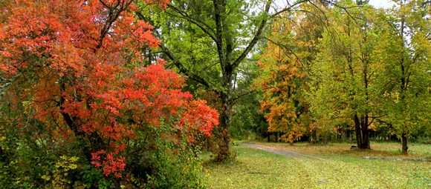
24 May – The European Day of Parks
Every year European Day of Parks takes place on and around 24th of May, marking the date when the first national parks in Europe were founded. It aims to bring people closer to nature and raise public awareness on the importance of the natural beauty preserved in Protected Areas and the importance of conservation and sustainable management of those places.
The European Day of Parks is a commemorative day for Protected Areas across Europe that was launched in 1999 by the EUROPARC Federation to celebrate Protected Areas throughout Europe.
The theme of the European Day of Parks 2015 is “Nature is Our Business”. This year's theme aims to showcase the 'business' of nature management, such as selling produce, cooperating with sustainable business, and nature guides.
The best friend of earth and of man is the tree. When we use the tree respectfully and economically, we have one of the greatest resources on the earth – said Frank Lloyd Wright.
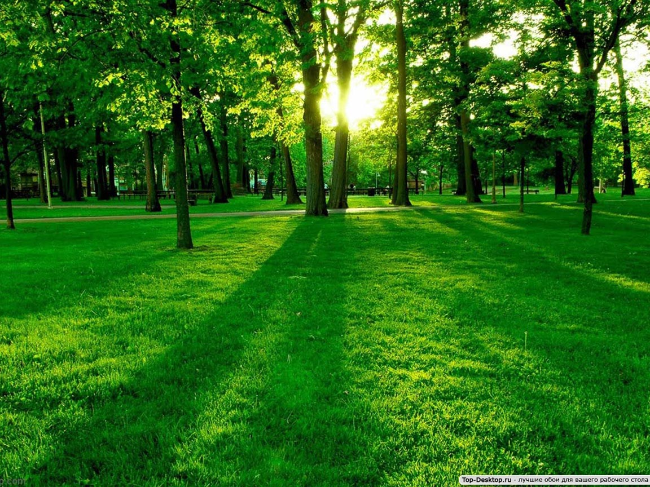
27 May – Nistru river Day
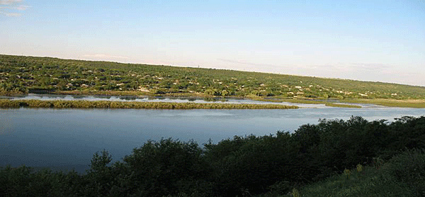
Every year, on the last Sunday of May Moldova celebrates the Nistru river Day. This day recognizes the great importance of the Nistru river for the economic sector of the country, ecological balance, as well as for the social sector, cultural history, including tourism.
The Nistru River is an important waterway flowing in the north-west area near the Black Sea coast. The river represents a focal point of human activities of all times and ages, both its sides being always densely populated.
Famous past travelers have often described in their travel journals the unique nature of this area. A lot of cultural, historical, ethnographic and archaeological objects are related Nistru river. This river has many names - Tyras, Danastris (Danastrus), Nistru. Its quiet and treacherous, cold and warm, friendly and hostile waters have seen many events and human beings.
The Nistru River is one of the largest rivers of southeastern Europe. Beginning its course in the western Ukraine, it rushes through the northern slopes of the Carpathian Mountains, and falls into the Dniester Liman of the Black Sea (southwest of Odessa).
The Dniester River is 1362 km long with a drainage area of 72 100 km2. The long and narrow drainage area is pressed between two adjacent rivers—Prut and Southern Bug (only about 50 km wide). The river network in the upper-mountain region of the drainage is particularly developed; the river crosses the Volyno-Podolskoye Plateau and receives only small tributaries in the lower regions.
Nistru Basin is located in the territory of two countries, Ukraine and Moldova. It crosses Moldova over a length of 700 km, the average width is 120 km.
The depth on the sand banks is 0.5-1.5 m, and on the stretches of water between islands - 0 to 2.5 m, the maximum being- 7.7 m. The speed of the river course varies between 0,3- 0.7 m /s and up to 2.0-2.5 m /s between islands.
The river bed is opened, in some places covered by trees, and lower course banks are covered with vegetation. The riverbed is mostly rocky - gravel and pebbles is getting into Nistru from the Carpathian tributaries, and in the southern part - sandy-muddy, and in the area wehere Nistru flows into liman there is a significant layer of mud. The banks are steep, with a height of 3-6 m, beaches are sandy and gravel, covered with grass, trees and shrubs, the predeltaic area is low, covered with sedges, reeds and bushes.
Nistru is one the 9 most important rivers of Europe and is one of the most interesting river in the region. Many cultures, peoples, traditions and customs have developed on its shores in the past.
In Moldova, SHS, an institution under the Ministry of Environment, is actively involved in the regional and international cooperation projects, that directly or indirectly promote the objectives of UN specialized agencies such as the World Meteorological Organization, or FAO (Food and Agriculture). An example is the active participation in the implementation of the project "Transition to high Value Agriculture" within the Moldova Compact, funded by the Millennium Challenge Corporation of the United States Government. The objective of the Transition to High Value Agriculture Project is to increase agricultural incomes by stimulating the production and improved marketing of high value fruit and vegetables. Under the project, Moldova’s MCC Compact funding will repair up to 11 large irrigation systems servicing 15,500 hectares, providing water for high value fruits and vegetables as well as higher yielding grain production. The project mentioned above provided installation of 10 real-time automated stations on the Nistru river and its tributaries.
Currently, hydrological observations network includes measurements on water level, flow, suspended sediments, temperature etc. The hydrological data obtained after a thorough analysis are included in "Hydrological Yearbook" and ,,State Water Cadastre ", which are used for planning and implementing measures to prevent dangerous phenomena, risks and environmental protection.
5 June - World Environment Day
World Environment Day (WED) is celebrated every year on 5 June to raise global awareness to take positive environmental action to protect nature and the planet Earth. It is run by the United Nations Environment Programme (UNEP).
It was established by the United Nations General Assembly in 1972 on the day that United Nations Conference on the Human Environment began. The first World Environment Day was celebrated in 1973. Since then it is hosted every year by a different city with a different theme.
World Environment Day (WED) is the United Nations’ principal vehicle for encouraging worldwide awareness and action for the environment. Over the years it has grown to be a broad, global platform for public outreach that is widely celebrated by stakeholders in over 100 countries. It also serves as the ‘people’s day’ for doing something positive for the environment, galvanizing individual actions into a collective power that generates an exponential positive impact on the planet.
The WED theme this year is "Seven Billion Dreams. One Planet. Consume with Care." The well-being of humanity, the environment, and the functioning of the economy, ultimately depend upon the responsible management of the planet’s natural resources. And yet, evidence is building that people are consuming far more natural resources than what the planet can sustainably provide.
Many of the Earth’s ecosystems are nearing critical tipping points of depletion or irreversible change, pushed by high population growth and economic development. By 2050, if current consumption and production patterns remain the same and with a rising population expected to reach 9.6 billion, we will need three planets to sustain our ways of living and consumption.
Consuming with care means living within planetary boundaries to ensure a healthy future where our dreams can be realized. Human prosperity need not cost the earth. Living sustainably is about doing more and better with less. It is about knowing that rising rates of natural resource use and the environmental impacts that occur are not a necessary by-product of economic growth.
World Environment Day is a celebration of all citizens regardless of country, race or other.
World Environment Day can be celebrated in many ways, namely bicycles parades, street rallies, green concerts, essays and poster competitions in schools, tree planting, recycling efforts, waste collection campaigns and more. This event is aimed to draw attention of the population on environmental issues at local, national and regional level.

TOGETHER WE CAN KEEP CLEAN ENVIRONMENT!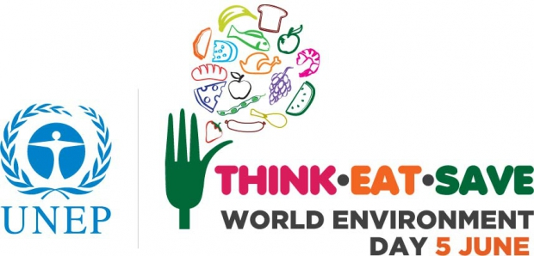
17 June - World Day to Combat Desertification
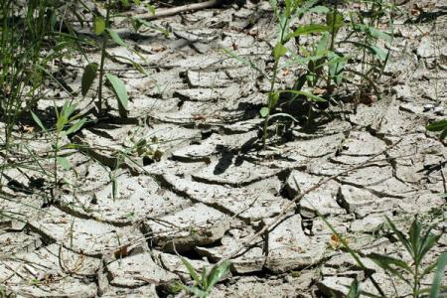
The World Day to Combat Desertification has been observed since 1995 to promote public awareness relating to international cooperation to combat desertification and the effects of drought.
In 1994, the United Nations General Assembly declared June 17 the "World Day to Combat Desertification and Drought" to promote public awareness of the issue, and the implementation of the United Nations Convention to Combat Desertification in those countries experiencing serious drought and/or desertification, particularly in Africa.
Ever since, country Parties to the Convention, organizations of the United Nations System, international and non-governmental organizations and other interested stakeholders have celebrated this particular day with a series of outreach activities worldwide.
The World Day to Combat Desertification is a unique occasion to remind everybody that desertification can be effectively tackled, that solutions are possible, and that key tools to this aim lay in strengthened community participation and co-operation at all levels.
The 2015 Theme is “No such thing as a free lunch. Invest in healthy soils” The World Day to Combat Desertification (WDCD) is observed worldwide on 17 June every year. The focus this year is “attainment of food security for all through sustainable food systems.”
With the slogan, ‘No such thing as a free lunch. Invest in healthy soil’, the 2015 observance calls for:
- A change in our land use practices through smart agriculture and adaptation to changing climate, especially in the dry fragile parts of the world where food shortages are becoming more and more severe
- Access to technology and land rights for small holder farmers who safeguard the environment and meet the food needs of millions of households, especially among the poorest households
- A balance in the land use for ecology and consumption, drawing on the best practices
- More investments in sustainable land practices so that sustainable food systems become the normal practice and
- More effective action on desertification whose effects on security, peace and stability are invisible yet real for the affected countries due especially to food and water scarcity and environmentally forced migration.
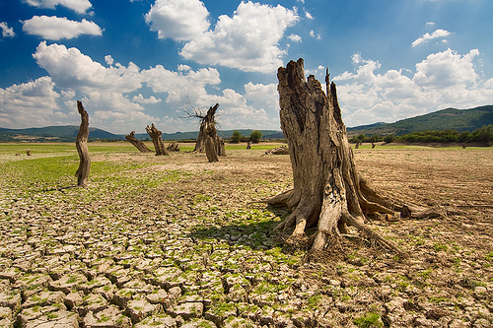
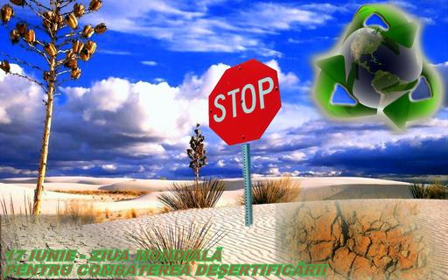
29 June - Danube Day

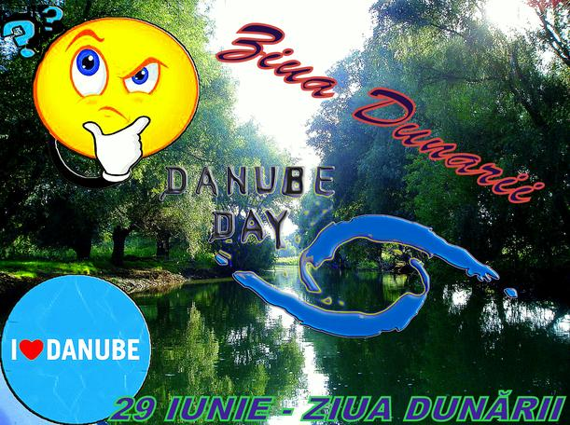
Danube Day is marked each year on the 29th of June, when the 14 countries of the Danube Basin jointly celebrate one of Europe's greatest river systems and the people and wildlife that rely on it.
The Danube is the backbone of a good part of Europe and this applies not only symbolically. Since the dawn of human civilization in this geographical area, the banks of the Danube were a privileged living space. Danube separated and connected in the same time kingdoms and empires, cultures and civilizations and has conditioned and influenced historical developments, has filled our collective mentality was and mythological deity.
In 2014, the 11th Danube Day was a mammoth celebration of the people and rivers of the Danube Basin. The ICPDR-led event paid tribute to 20 years of international cooperation since the signing of the 1994 Danube River Protection Convention. At events in 14 countries, thousands of people raised a smile, a cheer, a paint brush, a paddle or a tapping foot for their rivers. Around 500 government offices, businesses and NGOs organised actions that fostered a sense of Danube pride, solidarity and responsibility. The day was also a time for reflection and commemoration following the catastrophic flooding in May 2014.
The Danube Delta is one of the largest wetlands in the world that hosts rare species of fauna and flora as well as over 30 types of ecosystems. However, this unique natural value is under increasing pressure ad its biodiversity and ecosystems are highly threatened.
Given that the Danube gathers its waters from 18 countries and considering the complexity of the problems arising from the need to rehabilitate aquatic environment in the Danube river basin and achieving sustainable development for each country, an integrated approach of all stakeholders is critical. In this regard, we believe that the European Union Water Framework Directive is the most important instrument for achieving this objective.
We believe that this directive covers all necessary measures to achieve sustainable development, including environmental aspects of the river and at the same time, provides an opportunity of a better cohabitation between people and the environment.
In this regards, in February 2010 we have made a big step forward by approving the River Basin Management Plan at the International Commission for the Protection of the Danube River (ICPDR). The implementation of this management plan and, in particular, the program of measures aimed at achievement of a good status of all waters in the basin that is also a priority of the EU Danube Region Strategy.
Currently, we are in the preparatory phase of the second River Basin Management Plan at the level of the Danube basin and national basin. This new plan will build on experience gained in the first Management Plan and will focus particularly on measures aimed at improving the quality of the aquatic environment. Danube Strategy is an excellent opportunity to identify and promote a portfolio of projects, particularly those with transboundary relevance, covering the four main pillars of the Strategy: connectivity, environmental, economic and social development and increasing institutional capacity.
It is important to realize that only government action cannot bring improved water quality and environmental conditions. Each of us can do something to protect the ecosystem that sustains us. Industry, farms, local authorities, people of all ages must get together and act in a way to contribute to the conservation and, if necessary, restoration of the aquatic ecosystem that belongs to all of us. It is important to underline that any efforts will not reach the expected outcomes if the concerned communities and individuals will not change their attitude.
To achieve a clean environment, the dialogue between stakeholders should be based on effective, clear and honest, communication, without hidden agendas, with the only interest for promoting the partnerships and the principle of sustainable development.

9 August - International Day of Zoo and Parks
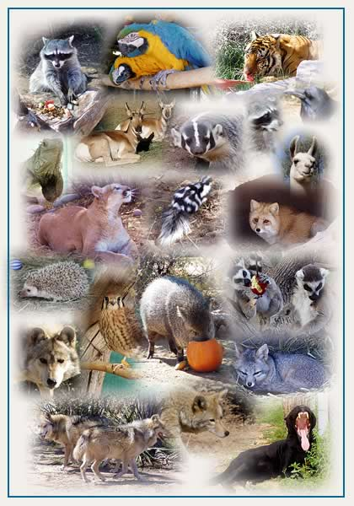
Every year on 9 August International Day of zoos and parks is celebrated the around the world, aimed at highlighting the importance of biodiversity conservation.
According to our legislation on the regime of protected natural areas, conservation of natural habitats, wild flora and fauna, our country set several categories of protected natural areas, defined by the management tasks assigned: scientific reserve; nature reserve; national park, natural park; natural monument; biosphere reserve; wetland of international importance (Ramsar site).
Currently, the protected natural areas in Moldova cover about 157 thousand ha, or 4.65 % of the total area of ​​the country, including 5 scientific reserves covering 19,378 ha, 1035 natural monuments covering 2907.2 ha area, 63 natural reserves covering ​​8009 ha, 41 landscape reserves covering 34,200 ha area, 21 monuments of landscape architecture, a botanical garden and a zoo. Wetlands of international importance area cover 94,705.5 ha.
Parks play an important role in environmental education. Among other things, parks contribute to the understanding of the conflicts that can arise between economic development and environmental protection. Promoting protect parks is often aimed at protecting the quality of life and preserving biodiversity. In our country we can be proud with scientific reserves, nature reserves, national parks, natural parks, natural monuments, biosphere reserves, Ramsar sites (wetland of national importance) or natural world heritage sites.
Zoo provides information about wildlife and are designed to promote environmental protection and conservation of rare and endangered species. The zoo administrators are actively participating in research activities that contribute to the conservation, exchange of information related to species conservation and, where appropriate, captive breeding, repopulation or reintroduction of species into the wild, education and raising public awareness about protecting biodiversity, sheltering animals under biological and conservation conditions, disease prevention and the veterinary care. Everybody is enjoying the parks and zoos, so everybody shall be responsible for protecting them.

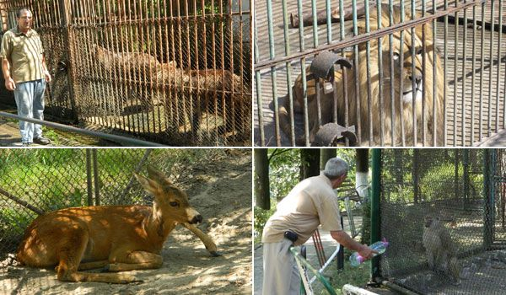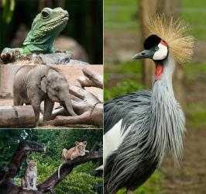
16 September - International Day for the Preservation of the Ozone Layer
September 16 was designated by the United Nations General Assembly as the International Day for the Preservation of the Ozone Layer.
This designation was made on December 19, 1994, in commemoration of the date, in 1987, on which nations signed the Montreal Protocol on Substances that Deplete the Ozone Layer.
The day is mainly intended to spread awareness of the depletion of the Ozone Layer and search for solutions to preserve it. World Ozone Day is also celebrated all around the world. Educators usually set aside this day to teach their students about the Ozone layer and many schools organize special events and activities to raise awareness. This is one event that everyone can experience and enjoy together.
In response to the prospect of increasing ozone depletion, the governments of the world crafted the 1987 United Nations Montreal Protocol as an international means to address this global issue. As a result of the broad compliance with the Protocol and its Amendments and Adjustments and, of great significance, industry’s development of “ozone-friendly” substitutes for the now-controlled chemicals, the total global accumulation of ODSs has slowed and begun to decrease. In response, global ozone depletion is no longer increasing. Now, with continued compliance, we expect substantial recovery of the ozone layer by the late 21st century. The day the Montreal Protocol was agreed upon, 16 September, is now celebrated as the International Day for the Preservation of the Ozone Layer.
ODSs are manufactured halogen source gases that are controlled worldwide by the Montreal Protocol. These gases bring chlorine and bromine atoms to the stratosphere, where they destroy ozone in chemical reactions. Important examples are the chlorofluorocarbons (CFCs), once used in almost all refrigeration and air conditioning systems, and the halons, which were used in fire extinguishers. Current ODS abundances in the atmosphere are known directly from air sample measurements.
Since the ozone layer absorbs UVB ultraviolet light from the sun, ozone layer depletion increases surface UVB levels (all else equal), which could lead to damage, including increase in skin cancer, weakens the immune system, reduces the harvest crops and destroys the biological diversity worldwide. Additionally, SDO are also greenhouse gas emissions that contribute to global warming.
Even if countries will continue to honor their commitments to the Protocol, the ozone hole over Antarctica will scar down the middle of this century.
The Montreal Protocol and its Amendments and Adjustments have been very successful in reducing the atmospheric abundance of ozone-depleting substances (ODSs). Certain industrial processes and consumer products result in the emission of ozone-depleting substances (ODSs) to the atmosphere. If the nations of the world continue to comply with the provisions of the Montreal Protocol, the decrease will continue throughout the 21st century.
What is being done towards complying with the obligations under the Montreal Protocol?
- Adjusting national legislative and regulatory framework with relevant international law;
- Improving data reporting on the import and consumption of ODSs, products and equipment containing ODSs;
- Organize mandatory training courses for technicians in refrigeration and air conditioning systems and provision of available tools / instruments;
- Development/procurement of professional training materials; Develop technical criteria (theoretical and practical requirements), adjusted with EU regulations for training of specialists in the refrigeration servicing and air conditioning;
- Development/procurement of professional training materials; Update the Code of good practices in refrigeration and air conditioning;
- Strengthen the capacity of the Customs Service: Development/procurement professional of training materials; Update Guide for customs officers; Theoretical and practical training of customs staff/ brokers; Equipping customs service with refrigerant identifiers.
- Education, information and public awareness; Strengthening the capabilities of Refrigeration Public Association in Moldova by supporting the creation and maintenance of a web page, organizing seminars on alternatives to HCFCs and equipment maintenance practices and upgrading of equipment for training purposes.

